

**Object Oriented Programming Lab**

**Name:** Pratham Kandari

**Sap Id:** 500097663

**Batch:** 7

**Experiment -5**

1. Write a Java program to implement the concept of importing classes from user defined package and created packages.

Ans:

package Mathematics;

import java.lang.*;

public class Arithmetics

{

public int add(int x,int y)

{

return x+y;

}

}

package Calculator;

import Mathematics.*;

class Demo

{

public static void main(String args[])

{

Arithmetics obj = new Arithmetics();

int a = obj.add(2,5);

System.out.println(a);

}

}

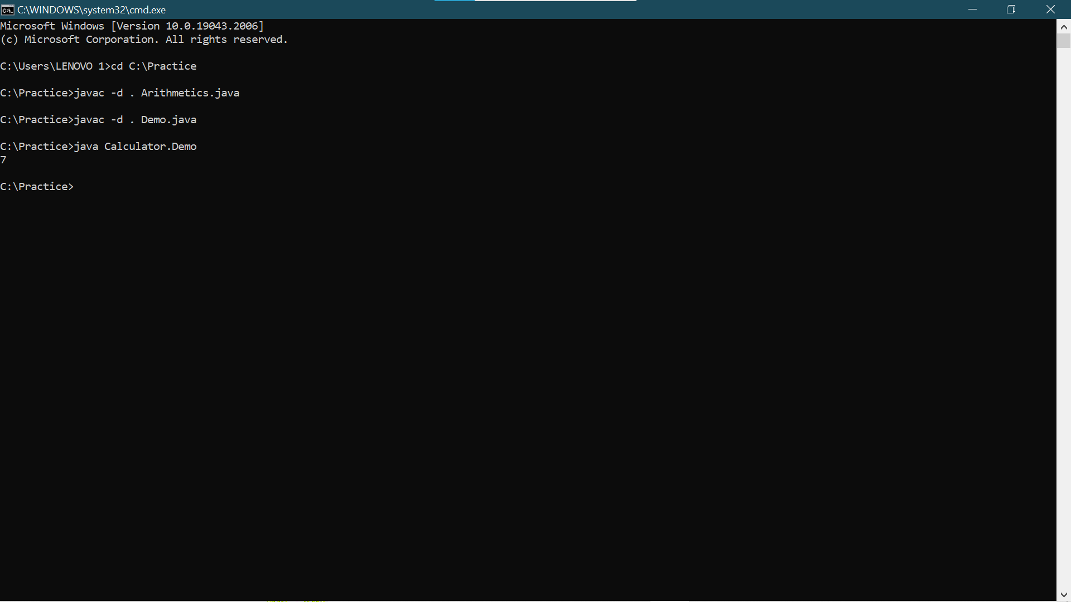

1. Write a program to make a package Balance. This has an Account class with Display_Balance method. Import Balance package in another program to access Display_Balance method of Account class.

Ans:

package Balance;

import java.lang.*;

public class Account

{

public void Display_Balance(int balance)

{

System.out.println("Your current balance is "+balance);

}

}

package Result;

import Balance.*;

class Output

{

public static void main(String args[])

{

Account obj = new Account();

obj.Display_Balance(100000);

}

}

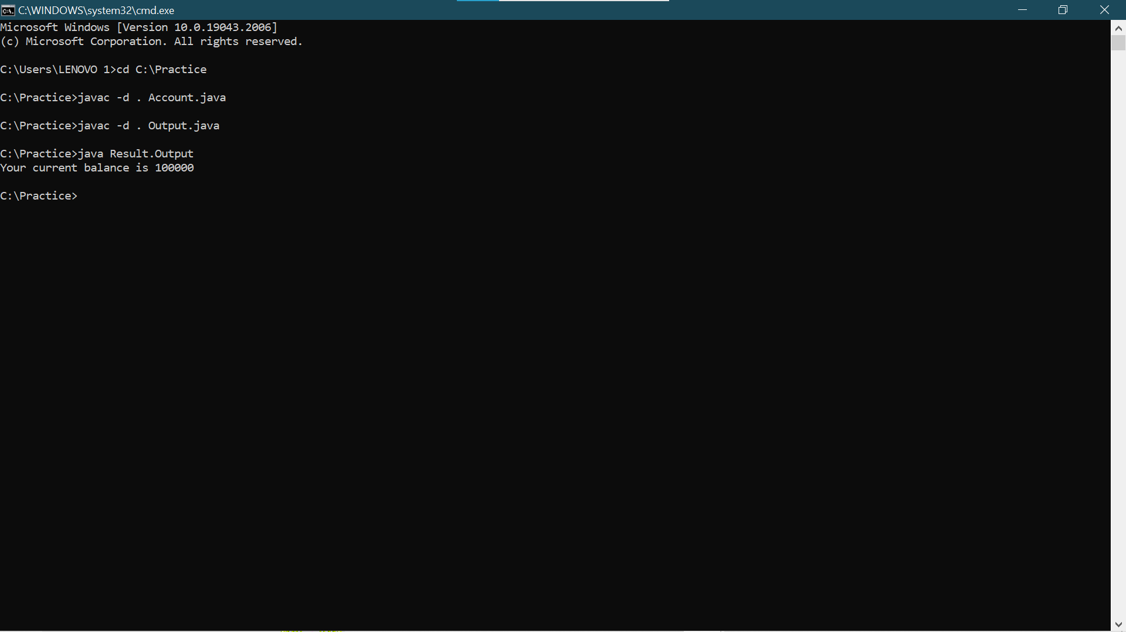

1. WAP to create a package p with class A with 4 types of access protected methods. How we will use these methods in different packages class i.e. there is main() in class B in package Q and 4 methods are in Class A in package p.

Ans:

package p;

import java.lang.*;

public class A

{

public void add1(int x, int y)

{

int result = x+y;

System.out.println(result);

}

private void add2(int x, int y)

{

int result = x+y;

System.out.println(result);

}

void add3(int x,int y)

{

int result = x+y;

System.out.println(result);

}

protected void add4(int x,int y)

{

int result = x+y;

System.out.println(result);

}

}

package q;

import p.*;

class ExperimentFive extends A

{

public static void main(String args[])

{

ExperimentFive obj = new ExperimentFive();

obj.add1(2,4);

obj.add2(1,2);

obj.add3(6,9);

obj.add4(4,6);

}

}

